
Pay school fees online
[School/District Name] offers a simple, secure way to pay online through RevTrak. Families can pay PowerSchool fees and other school-related costs online, including forms, [meals, events,] activities, and more.

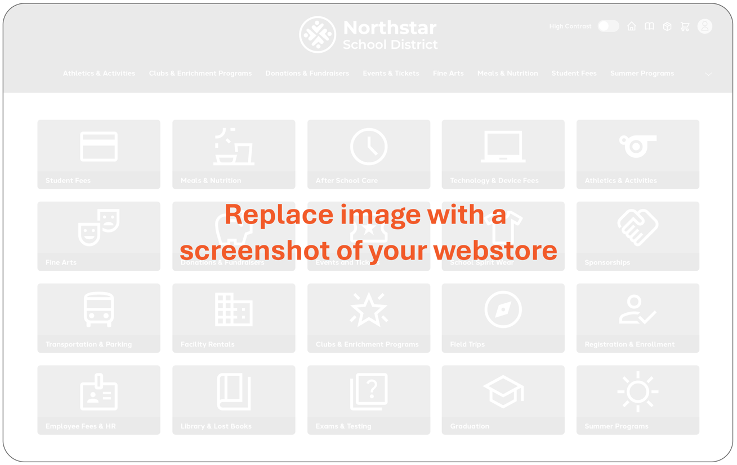


[Webstore URL goes here]

Pay school fees online
- Pay from a phone, tablet, or computer
- Avoid sending cash or checks to school
- Pay for multiple fees or items in one checkout
- View receipts and payment history anytime

For questions, please contact the office at:
[Phone / Email]

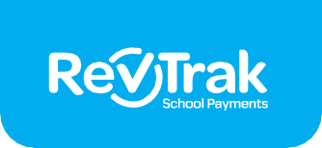
How to pay online

Log in to PowerSchool
1
via internet browser (not the app).
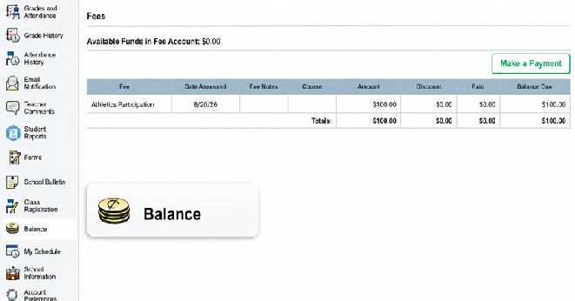


Click “Balance”
2
from the menu on the left-hand side of the screen.


Click the green “Make a Payment” button on the
right-hand side of that screen.

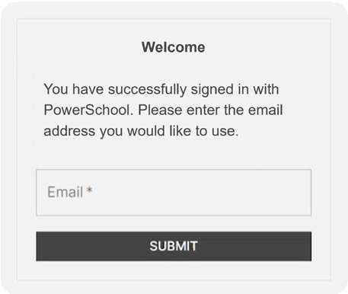

Link Your Account
3
You will be redirected to our RevTrak webstore. Confirm your email address, and a RevTrak account will automatically be created for you and linked to your PowerSchool account.

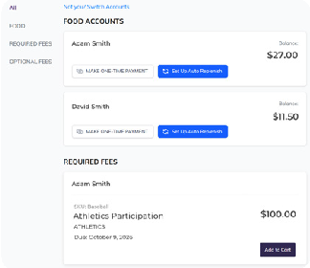

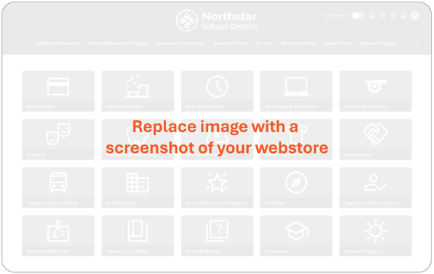
Add to Cart
4
after reviewing student fees.

Find Fees and Items
You can add additional fees or items to your cart by going to the webstore main page - just click our logo on the top left.

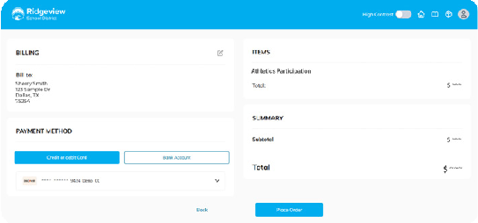

Checkout
5
Select ‘Checkout’ from your cart, review your information and payment method, and then click ‘Place Order’.


You can log in to RevTrak anytime to view receipts, check previous payments, or update saved payment information.

