
Pay school fees online
[School/District Name] offers a simple, secure way to pay online through RevTrak. Families can pay Skyward fees and other school-related costs online, including forms, [meals, events,] activities, and more.

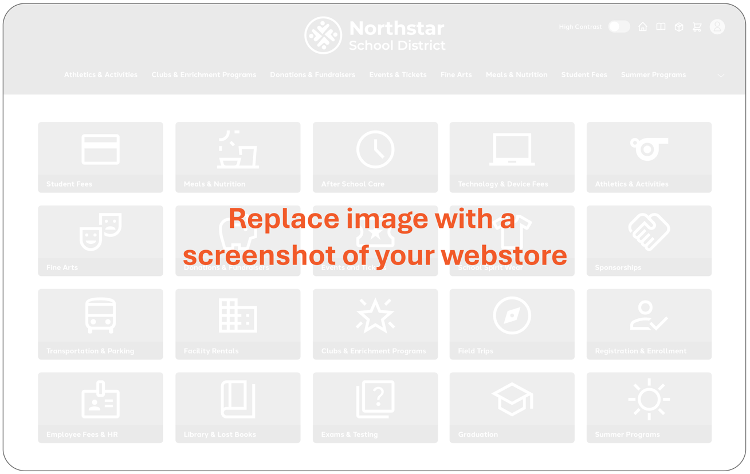



[Webstore URL goes here]

Pay school fees online
- Pay from a phone, tablet, or computer
- Avoid sending cash or checks to school
- Pay for multiple fees or items in one checkout
- View receipts and payment history anytime

For questions, please contact the office at:
[Phone / Email]

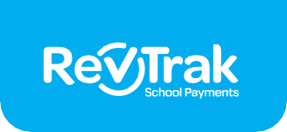
How to pay online

Sign in to the Skyward Parent Portal
1
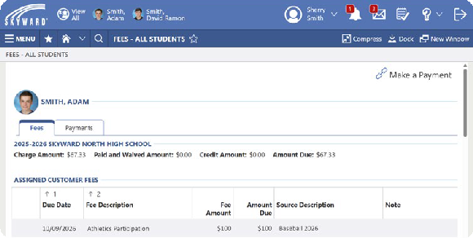
using your Skyward Username and Password.


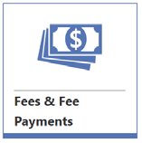

Click ‘Fees & Fee Payments’ or ‘Food Service’
2
Click the link in the top right corner

to make a payment Account.

Link Your Account
3
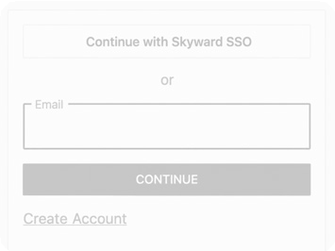

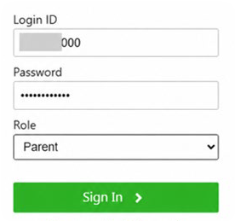
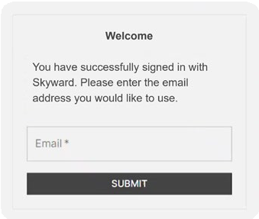
You will be redirected to RevTrak. Click ‘Continue with Skyward SSO’ and enter your Skyward* login credentials and select ‘Parent’ as your role. Click ‘Sign In’
Confirm your email address, and a RevTrak account will automatically be created for you and linked to your Skyward account.
*If Skyward SSO is not enabled, you will be prompted to sign in or create a RevTrak account.
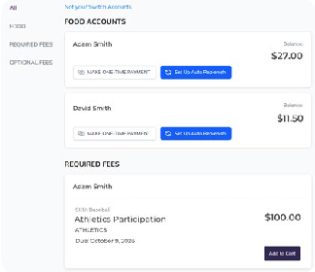

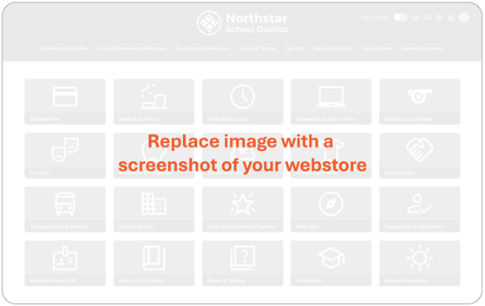
Add to Cart
4
after reviewing student fees.

Find Fees and Items
You can add additional fees or items to your cart by going to the webstore main page - just click our logo on the top left.

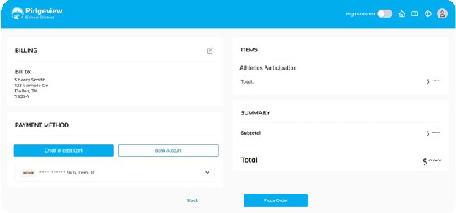

Checkout
5
Select ‘Checkout’ from your cart, review your information and payment method, and then click ‘Place Order’.


You can log in to RevTrak anytime to view receipts, check previous payments, or update saved payment information.

