
Pay school fees online
[School/District Name] offers a simple, secure way to pay online through RevTrak. Families can use RevTrak to complete payments for school-related fees, forms, [meals, events,] activities, and more.

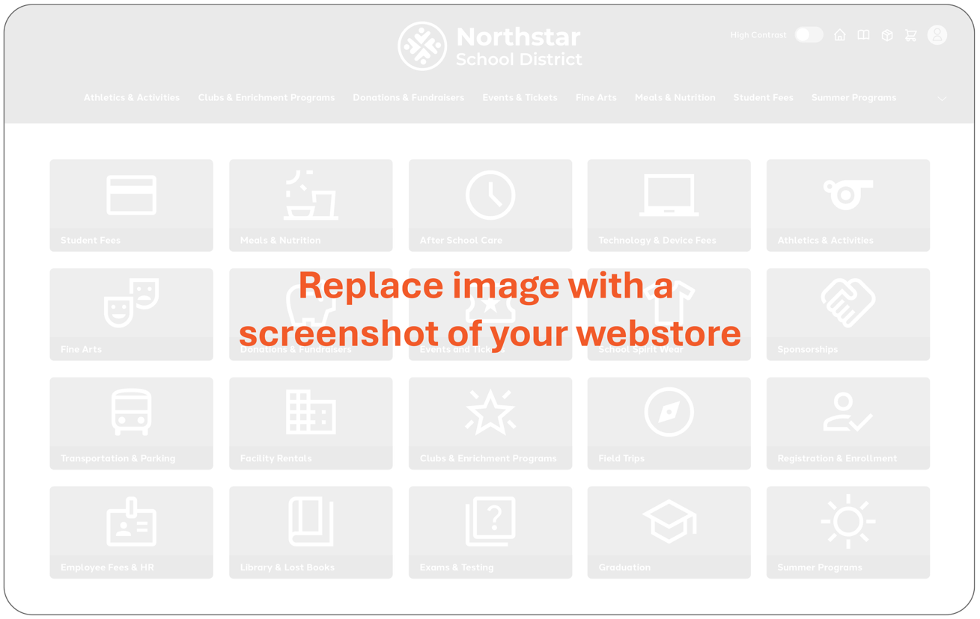
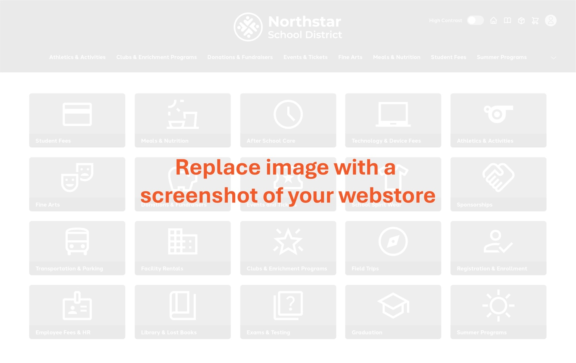


[Webstore URL Goes Here]

Pay school fees online
- Pay from a phone, tablet, or computer
- Avoid sending cash or checks to school
- Pay for multiple fees or items in one checkout
- View receipts and payment history anytime

For questions, please contact the office at:
[Phone / Email]

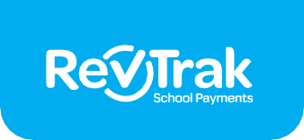
How to pay online
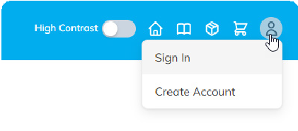
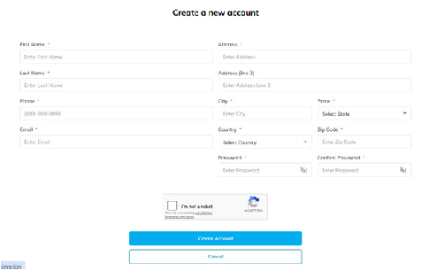

Create Account & Sign in
1

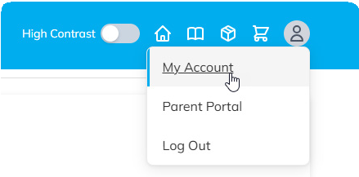

2 Add Payment Method
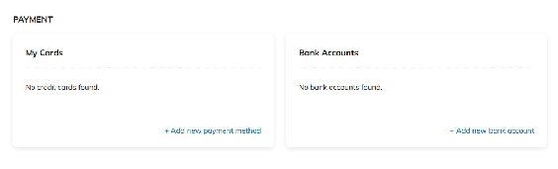
Under ‘My Account’, add a
Debit/Credit Card or Bank Account.

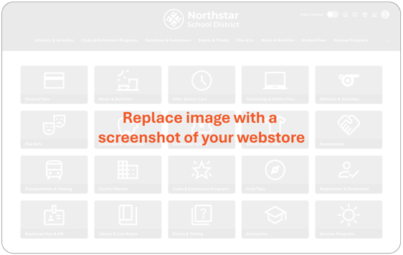

Add to Cart
3
Find the fee or item you need in the webstore, enter any needed details, and add it to your cart. You can add multiple items before checking out.

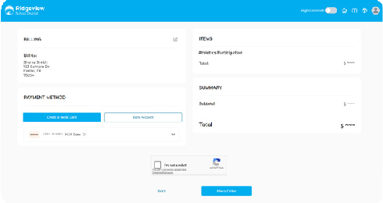

Checkout
4
Select ‘Checkout’ from your cart, review your information and payment method, and then click ‘Place Order’.


You can log in anytime to view receipts, check previous payments, or update saved payment information.

